Otley Local History Group
A group of people from in and around Otley, all with an interest in the history of the village. We don’t have regular talks or speakers, but meet four times a year at the White Hart, in order to co-ordinate research and projects which record village history in various ways.
Members of the Group have now completed six projects relating to the history of Otley:
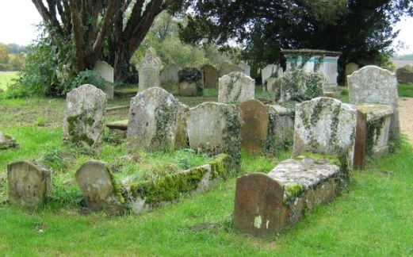
“Memorial inscriptions at St Mary’s Parish Church, Otley”

This book contains details of the memorials at the Parish Church. Photographed by Janice and Ken Wood, and transcribed by Sally Whiffing.
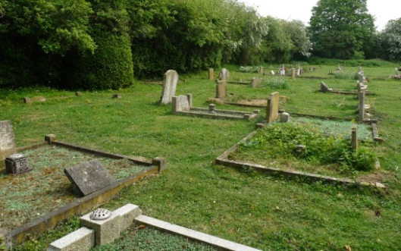
“Memorial inscriptions at Otley Baptist Chapel”

This book contains details of the memorials at the Baptist Chapel. Photographed by Janice and Ken Wood, and transcribed by Sally Whiffing.
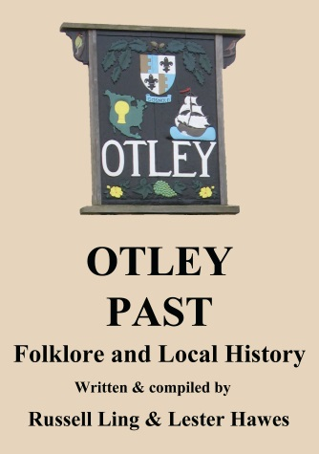

“Otley Past: Folklore and Local History”

This book was written by Russell Ling and Lester Hawes and contains many stories, photographs and memories of life in the village over the past hundred years.

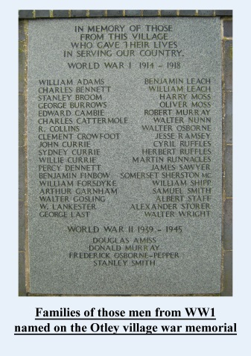

“Families of those men from WW1 named on the Otley Village war memorial”

This book was written by Ken Fortune and gives background information on the families of over 30 men from Otley who died during the First World War.

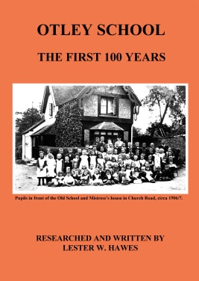

“Otley School: the first 100 years”

This was written by Lester Hawes covers the history of the school between 1839 and1939. It was published in March 2013, to coincide with the centenary of the present school building.

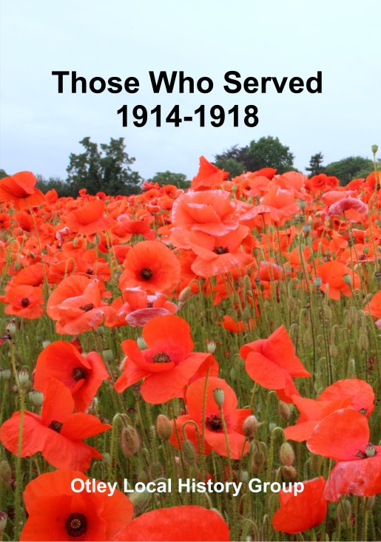

“Those Who Served: 1914-1918”

This book marks the first steps in recording the families and background of over 120 men and women of the parish who served in the First World War. Many were born in Otley, others lived or worshipped in the parish before or during the Great War. The book combines previous information on those who are named on the village war memorial, as well as those who survived.

More information is already being discovered – can you help us to discover more?

Co-ordinator of Otley Local History Group and Local History Recorder:
historian2007@gmail.com

